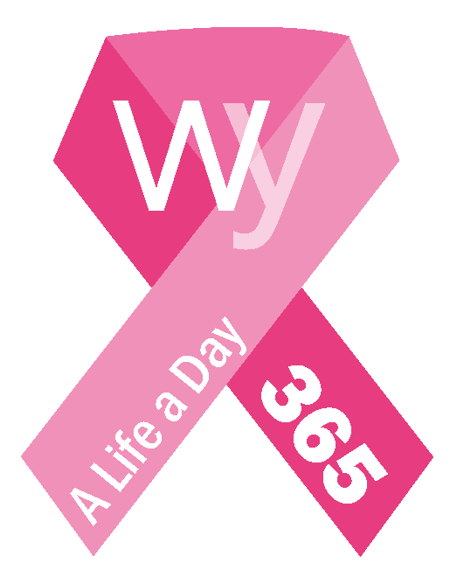

For Release on: April 17, 2019 or after
Campaign Contact: Laurie Heath
Phone: (307)840-WBCI
Email: info@wyomingbreastcancer.org

Wyoming Breast Cancer Initiative Announces New Fundraising Campaign
WBCI 365
On average, every single day, a Wyoming woman or man receives a breast cancer diagnosis.
Wyoming, we can do better.
Your donation of $1 a day for 365 days will allow the Wyoming Breast Cancer Initiative (WBCI) to change the future for Wyoming women, men, and their families through WBCI community grants and vouchers.
The objective of the WBCI 365 campaign is to build capacity and grant sustainability for WBCI through pledges from individuals, foundations and businesses.
Donors can choose to donate $1 a day (which is $30/month) for the length of 1-5 years. The WBCI is seeking 365 donors to commit $365/year in honor of every Wyoming woman or man impacted by breast cancer. Donors can sign up through WBCI’s safe and secure website (www.wyomingbreastcancer.org), text ‘365WYO’ to 50155, or email info@wyomingbreastcancer.org for information on donor recognition and donation options. Donations can be committed under an individual or businesses name, or in memory/celebration of a loved one.
The Wyoming Breast Cancer Initiative has a mission to increase breast cancer awareness and prevention across Wyoming. Since 2016, the WBCI raises funds through various volunteer-led events throughout the state that are then granted into community breast cancer organizations and into a statewide early detection voucher program. To date, the WBCI has granted over $300,000 into programs covering all Wyoming counties. Check out events, grants and other information at the website.
Money raised in Wyoming, stays in Wyoming.
As a breast cancer survivor, I know that early detection saves lives. As a longtime advocate, I know the great work of the Wyoming Breast Cancer Initiative saves lives. Please join me in pledging your support for the WBCI 365 campaign to continue this important mission to ‘educate, advocate and eradicate’ breast cancer. Remember, WBCI funds stay in Wyoming to help Wyoming women, men and families. Thank you! -Bobbi Barrasso, WBCI Board member
As a women’s health care provider and breast cancer surgeon, I often see women with advanced cancer. This is a disheartening situation since early detection can significantly improve survival from breast cancer. I support the Wyoming Breast Cancer Initiative’s commitment to Wyoming to provide grants across the state for early detection, treatment services and survivor support. They truly fill a need in our great state. Lisa Burton, M.D.
More information can be found at www.wyomingbreastcancer.org or follow on social media.

